Creating a Database and Querying Data  
DAD 220 Intro to Struct Database Environment

Sergio Mateos

Southern New Hampshire University

# DAD 220 Database Documentation Template

Complete these steps as you work through the directions for Project One. Replace the bracketed text with your screenshots and brief explanations of the work they capture. Each screenshot and its explanation should be sized to approximately one quarter of the page, with the description written below the screenshot. Follow these rules for each of the prompts and questions below. Review the example document located in the Project One Supporting Materials for assistance.

## Step One: Create a Database

1. Text

   Description automatically generatedNavigate to your online integrated development environment (IDE). List and record the SQL commands that you used to complete this step here:

First, I initiated the SQL with the command mysql and show the databases.

1. Text

   Description automatically generatedCreate a database schema called QuantigrationUpdates. List out the database name. Provide the SQL commands you ran against MySQL to successfully complete this in your answer:

The QuantigrationUpdates database was created with the command CREATE DATABASE QuantigrationUpdates, then to confirm it was created I use the command SHOW DATABASE, and I use the database using USE QuantigrationUpdates.

1. Using the entity relationship diagram (ERD) as a reference, create the following tables with the appropriate attributes and keys:
   1. A table named **Customers** in the QuantigrationUpdates database, as defined on the project ERD. Provide the SQL commands you ran against MySQL to complete this successfully in your answer:

I create a table called “Customer” with the command CREATE TABLE Customer, which contains CustomerID, FirstName, LastName, Street, City, State, ZipCode, Telephone, and PRIMARY KEY. I check the table by using the command DESCRIBE Customer.

* 1. Text

     Description automatically generatedA table named **Orders** in the QuantigrationUpdates database, as defined on the project ERD. Provide the SQL commands you ran against MySQL to complete this successfully in your answer:

I create a table called “Orders” with the command CREATE TABLE Orders, which contains OrderID, CustomerID, SKU, Description, and PRIMARY KEY. I verify the new table with the command DESCRIBE Orders.

* 1. 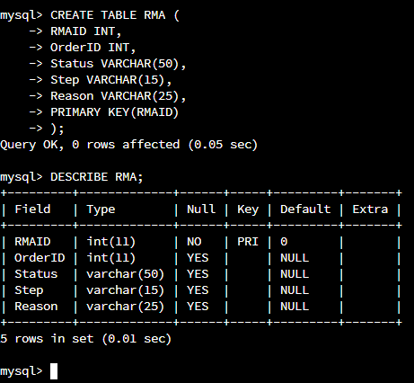 A table named **RMA** in the QuantigrationUpdates database, as defined on the project ERD. Provide the SQL commands you ran against MySQL to complete this successfully in your answer:

I create a table called “Orders” with the command CREATE TABLE RMA, which contains RMAID, OrderID, Status, Step, Reason, and PRIMARY KEY. I verify the new table with the command DESCRIBE RMA.

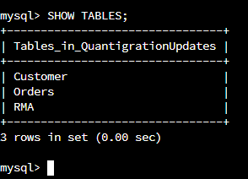

The command SHOW TABLES to verify all our tables created.

## Step Two: Load and Query the Data

1. **Import the data from each file into tables.** 
   * Use the QuantigrationUpdates database, the three tables you created, and the three CSV files preloaded into Codio.
   * Use the import utility of your database program to load the data from each file into the table of the same name. You will perform this step three times, once for each table.

1. **Write basic queries against imported tables to organize and analyze targeted data.** For each query, replace the bracketed text with a screenshot of the query and its output. You should also include a 1- to 3-sentence description of the output.
   * Write an SQL query that returns the **count** of orders for customers located only in the city of Framingham, Massachusetts.
     1. How many records were returned?

The output of the command displays that 505 of orders are located only in the city of Framingham, Massachusetts. 505 is a low amount of orders, this output can help the business owner to know the amount of the population or needs. Framingham, Massachusetts is a small town, so the data is reliable.

* + Write an SQL query to **select all** of the Customers located in the state of Massachusetts.
    1. Use a WHERE clause to limit the number of records in the Customers table to only those who are in Massachusetts.
    2. Text

       Description automatically generatedRecord an answer to the following question: How many records were returned?

The count of customer in state of Massachusetts is 982. The data display and help us to analyze the small amount of customer in Massachusetts. Business have opportunity to enter to Massachusetts since the demand could be potentially high.

* + Write a SQL query to insert four new records into the Orders and Customers tables using the following data:

**Customers Table**

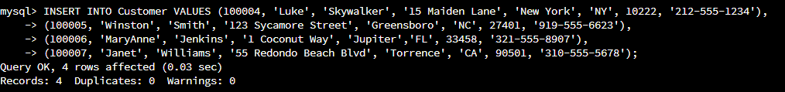

| **CustomerID** | **FirstName** | **LastName** | **StreetAddress** | **City** | **State** | **ZipCode** | **Telephone** |
| --- | --- | --- | --- | --- | --- | --- | --- |
| 100004 | Luke | Skywalker | 15 Maiden Lane | New York | NY | 10222 | 212-555-1234 |
| 100005 | Winston | Smith | 123 Sycamore Street | Greensboro | NC | 27401 | 919-555-6623 |
| 100006 | MaryAnne | Jenkins | 1 Coconut Way | Jupiter | FL | 33458 | 321-555-8907 |
| 100007 | Janet | Williams | 55 Redondo Beach Blvd | Torrence | CA | 90501 | 310-555-5678 |

The SQL insert four new customers to the table “Customer”, the command INSER INTO Customer VALUES is used to insert the new customers. Each customer has unique information. I display the table with the command SELECT * FROM Customer WHERE CustomerID IN (100004, 100005, 100006, 100007).

**Orders Table**

| **OrderID** | **CustomerID** | **SKU** | **Description** |
| --- | --- | --- | --- |
| 1204305 | 100004 | ADV-24-10C | Advanced Switch 10GigE Copper 24 port |
| 1204306 | 100005 | ADV-48-10F | Advanced Switch 10 GigE Copper/Fiber 44 port copper 4 port fiber |
| 1204307 | 100006 | ENT-24-10F | Enterprise Switch 10GigE SFP+ 24 Port |
| 1204308 | 100007 | ENT-48-10F | Enterprise Switch 10GigE SFP+ 48 port |

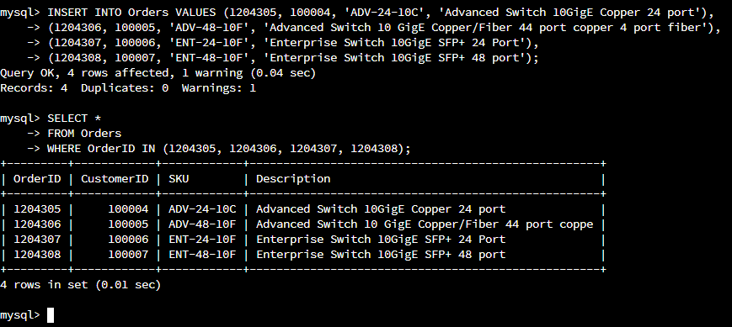

The SQL insert four new orders to the table “Orders”, the command INSER INTO Orders VALUES is used to insert the new orders. Each of the orders has unique information. I display the table using the command SELECT * FROM Orders WHERE OrderID IN (1204305, 1204306, 1204307, 1204308).

* + In the Customers table, perform a query to count all records where the city is Woonsocket, Rhode Island.
    1. How many records are in the Customers table where the field “city” equals “Woonsocket”?

The database shows all the customer in the city Woonsocket, Rhode Island which is 7. Woonsocket has low volume on customers so which make difficult to the business to reach since the cost of customer may be higher than the profit.

* + In the RMA database, update a customer’s records.
    1. Write an SQL statement to select the current fields of **status** and **step** for the record in the **RMA** table with an **orderid** value of “5175.”
       1. What are the current status and step?

The status is “Awaiting customer Documentation” and the step is “Pending” in the OrderID 5175. The account has not been completed.

* + 1. Write an SQL statement to update the **status** and **step** for the **OrderID**, 5175 to **status** = “Complete” and **step** = “Credit Customer Account.”
       1. What are the updated **status** and **step** values for this record?

The update will change the status of the order 5175 and now will be change to status “Complete” and step “ Credit Customer Account”. This completes the order from the RMA. I also display the data to verify the updates.

* + Delete RMA records.
    1. Write an SQL statement to delete all records with a reason of “Rejected.”
       1. How many records were deleted?

First, I display how many records were “Rejected” on RMA which display 596. After deleting the data, I displayed again, and the data shows 0. Which indicates that the data was deleted successfully.

1. **Update your existing tables** from “Customer” to “Collaborator” using SQL based on this change in requirements. Provide the SQL commands you ran against MySQL to complete this successfully in your answer:
   1. Rename all instances of “Customer” to “Collaborator.”

The table “Customer” would be update to “Collaborator”. Now all the data rom “Customer” table now would be located into “Collaborator”. I verify the update by displaying the tables.

1. 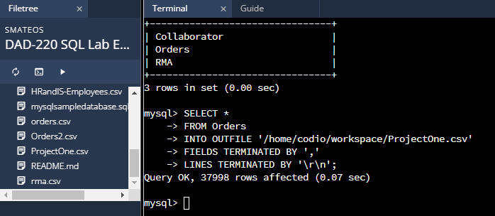**Create an output file of the required query results.** Write an SQL statement to list the contents of the **Orders** table and send the output to a file that has a .csv extension.

I created an out file in the codio workspace which I named “ProjectOne.cvs”. I minimize the window and placed next to the last code to be easier to identify.